**Assignment 3**

1. When Page loads Display your **Full Name** and **NUID** on the screen
2. On page load
   1. Table should not be expanded when page loads
   2. Submit button to be disabled and grayed out and it should not be clickable
3. On Click of **Add New Student** Button
   1. Add a new student with dummy values and dummy values should be dynamically added e.g for row 4 the values will be Student 4, Teacher 4 etc. and for row 5 the values will be Student 5, Teacher 5 etc
   2. For newly added rows make sure existing CSS are applied too
   3. **NOTE** – The table should always have records in order, even after deleting and adding students the table should have student number in orderly fashion and not skip any numbers. (e.g. if there are 5 records and student 5 is deleted and a new student is crated it should create student 5 again and not 6)
4. After successful add of the record display the pop-up message with newly added student name in the popup message e.g. if you have added row 4 for student 4 then display “**Student 4 Record added successfully**” and display error message in case add of record addition failed.

1. On **Selecting** any of the **checkboxes**,
   1. Background color to be changed for the particular row to “Yellow”
   2. Submit button to turn orange
   3. A delete button should get added **dynamically** in **DELETE column**
   4. An Edit button should get added **dynamically** in **EDIT COLUMN**
2. On Click of delete button it should delete the entire row when clicked. Also, pop-up message should be displayed by having student name in the popup message e.g. if you have deleted row 4 for student 4 then display “**Student 4 Record deleted successfully**”
3. On click of Edit button it should only display a prompt box with a message and a text box e.g. if you are editing student 2 details then edit pop up should display as
   1. **Title** – “**Edit details of Student 2**”
   2. **Textbox** – A text box for user input
   3. **2 Buttons “OK” and “Cancel”**
   4. On click of “OK” You **do not** need to update the table with the new data just show a message “**Student 2 data updated successfully**” if you have some data inside the field and when “**Cancel**” button is clicked pop up will be closed
4. On **Deselecting** the checkbox
5. Make the row background color white again.
6. Also, if none of the rows are selected, the Submit button should be Grayed out again(disabled). (i.e., if 1 or more of the checkboxes are selected, the Submit button will be enabled and background color will be yellow. If none are selected, it will be disabled and background set to Gray)
7. DELETE and EDIT button in those de-selected rows will be **hidden**
8. Clicking on any of the green arrows will expand the particular row. Clicking it again will collapse it (i.e., toggle view on click)
9. Assignment must be submitted on your **PRIVATE** **GitHub account (use Northeastern email account)** and **zip** file must be submitted on **CANVAS** and github URL of assignment in the canvas remarks

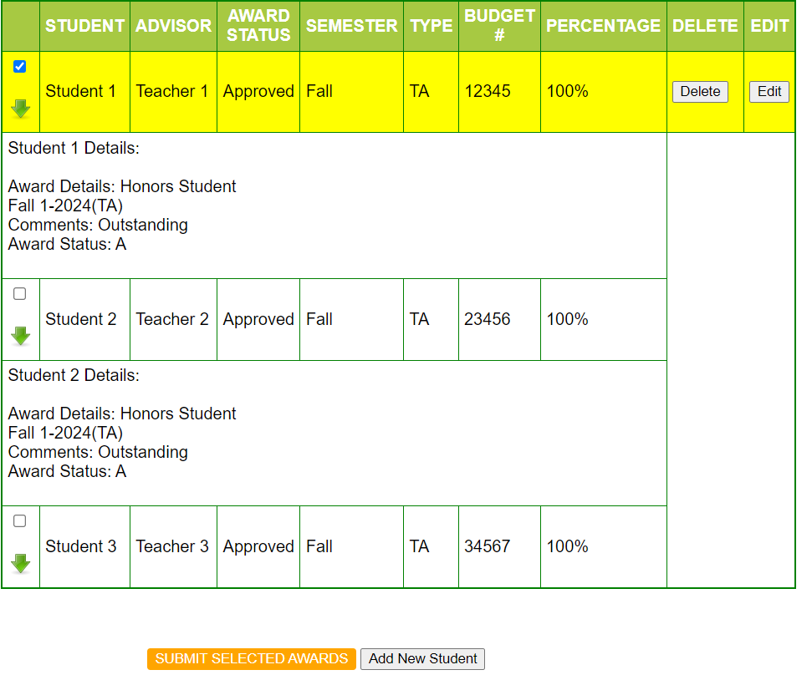

NOTE- Images in the assignment above are just for reference, cover all the requirements mentioned in the assignment.